# **Leaders at Risk**

**Cru Inner City Team Leaders- 9/24/21**

“They will be called oaks of righteousness, a planting of the Lord for the display of his splendor” Isaiah 61:1-3

Are You Flourishing or Withering? Honest or At Risk? (Isaiah 1:30)

**Leader Examination**

What feedback have I gotten that has exposed my heart or character problems? How did I respond?

# **I. Identifying an At Risk Leader**

**What I have learned about At Risk Leaders and Moral Failure…**

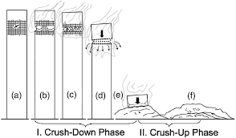

**“Progressive Collapse”**

-Moral Purity or Failure at its core is not about behavior but rather an orientation to God and His design for life.

-**The roots** of leader failure are found in three areas…

Jesus answered, “I am the way and the truth and the life. No one comes to the Father except through me.” John 14:6

**Assaults of the enemy** in the Garden and in the Desert Temptations- **Matthew. 4: 1-11**

          A) **Life**—“turn these stones into bread"—Do not rely on God for life- depend only on yourself!

          B) **Truth**- “hast God really said”— “If you are the son of God…” –Do not trust God... doubt and reject God’s truth and reality

          C) **Way**— Sovereign Kingship- “if you will fall down and worship me” vs. 9-10 –Do not worship Him or submit to His power and Lordship –Take Control Yourself!

# **II. Red Flags …Am I At Risk?**

## **What are the warning signs of the at risk leader?**

**Behavior/Attitude towards life/relationships.** Is there hiding, secrecy and isolation? John 15; I Cor 13; Romans 12:9, 13,15

*\*Lack of close relationships with others.* Do others know you?

*\*Lack of inner Life/Disconnection from God*. Is there life and passion or are you distant from God?

*\*Hiding behind his/her performance.* Are you a high achiever and performer but neglecting your heart and relationships?

*\*Incongruency and compartmentalization―* Are there signs of duplicity?

*What are you depending on or attaching to for life?*

**Behavior/Attitude towards authority, power, and control.** Can they worship and submit to God? Respect others? John 14:21; James 4:10; Eph 5:21

*\*Power imbalances in marriage, team, or other key relationships*. Do you have to be in control? Are you always letting others control you?

*\*An excessive desire for leadership or power*. Do you have a servant’s heart? Do you have to be the one in charge? Does you use people or serve them?

*Territorial control issues*- This is where the leader has the stance that “mine” is more important than the greater good. Is there a sense of possessiveness- these are my people, my team, my money/budget?

*\*Assuming their leadership position is based on talent rather than God's blessing.* Is there confusion between God’s blessings and their achievements?

*\*A sense of specialness or entitlement*. Do you expect special treatment for your position or status?

**Behavior/Attitude towards truth, reality, responsibility and pain.** Eph 4:15, 25; Heb 5:14; 2 Thess 3:6-13; Col 3:23-24; John 15:16

**How does the leader respond to feedback?**

*\*Blame Shifting and Minimization*. *Denial of Responsibility.* Do you admit mistakes, accept responsibility, and make restitution? Explain away your responsibility…?

*\*Ignoring feedback, attacking the messenger or becoming the victim.* Do you take the posture of a victim when given feedback?

*\*A lack of self-awareness*. Are you able to admit “I have a problem” and “I need help”?

*\*No track record of forgiveness or resolved conflict*. Can you admit when you are wrong? Forgive?

**How does the leader respond to failure and living in a fallen, imperfect world?**

*\*Ignoring or Covering up Problems*: Do you acknowledge your mistakes or sin? Is there a pattern of lying or deceit?

*\*Protest, Anger and Rage:* How do you respond when things do not go their way? Demand? Get angry?

*\*Theological imbalances*: Are you judgmental and pharisaical? Do you act like “perfection is the goal”? Do you tend to shame or lay guilt on others?

**As you look at this list, ask yourself:**

*-What are my red flags? (Circle them)-What might that red flag be rooted in?*

*-How do I know when I am becoming at risk as a leader?*

-Leaders at risk often drift into two dangerous patterns:

1. ______________ “it all depends on me” (2 Cor. 12:9)

2. _______________ “shame and fear” (Heb. 4:14-16)

# **III. Lessons from those who have fallen and are recovering!**

1) V**alue growth**- where does it show up in your calendar?

2) Get to the **core** of who you are

3) **Do not minimize** your family of origin…know your story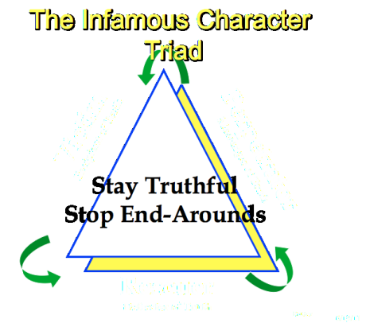

4) Recognize it does not all depend on me… take time to **reflect**…

**IV. Addressing an At-Risk Leader**

Copyright © 2019 by Dr. Marc V. Rutter

All Rights Reserved